**TalantaHR SYSTEM DOCUMENTATION**

**2023**

**(Version: 0.2.0)**

**TalantaHR SYSTEM OVERVIEW**

**Version 0.2.0**

**Introduction**

Welcome to the TalantaHR System, version 0.2.0 – where modern technologies converge to streamline and enhance HR operations. This system is a react (Next.js-powered) web application, utilizing a robust stack of dependencies to ensure efficiency, maintainability, and a delightful user experience.

**Key Dependencies**

1. **Runtime Dependencies**

* @emotion/react (version 11.1.1): Library for styling react components with emotion.
* @emotion/styled(version 11.11.0): Emotion bindings for writing styled components with CSS
* @mui/icons-material(version 5.14.9): Material UI icons
* @mui/material(version 5.14.9): React components implimenting Google’s material design.
* @reduxjs/toolkit(version 1.9.5): Toolkit for effective Redux development.
* @types/node(version 20.6.0): Typescript types for Node.js
* @types/react(version 18.2.21): TypeScript types for React
* @types/react-dom(version 18.2.7): Typescript for ReactDOM
* @typescript-eslint/scope-manager(version 6.7.0): Typescript ESLint scope manager
* cross-env: (version 7.0.3): Cross-platform setting for environment scripts
* formik(version 2.4.4): Form Library for react and react netive
* next(version 13.5.4): React framework for building server-rendered applications.
* react(version 18.2.0): React Library.
* react-dom(version 18.2.0): React DOM Library
* react-redux(version 8.1.2): Official react bindings for redux
* react-router-dom(version 6.16.0): Declaring routing for react.js
* react-toastify(version 9.1.3): Notification Library for react
* typescript(version 5.2.2): Typed superset for Javascript
* yup(version 1.2.0): Javascript schema builder for value parsing and validation.

1. **Development Dependencies**

* @typescript-eslint/eslint-pligin(version 6.7.0): Typescript ESLint plugin.
* eslint(version 8.49.0): Linting utility for javascript and JSX
* eslint-config-next(version 13.4.9): ESLint configurationfor Next.js projects.
* eslint-config-prettier(version 9.0.0): Turns off ESLint rules that conflict with Prettier
* husky(version 8.0.0): Git hooks made easy
* prettier(version 3.0.3): Optimated code formatter

**Getting Started**

npm install

npm run dev

**MODULE DOCUMENTATION**

1. **Organization Authentication**

**-** API endpoint

<https://api/talantahrm.com/organization/{organization}/v1/validate>

- Injection Points: everytime on focus. (on every page)- creates a hook for this and import to every page

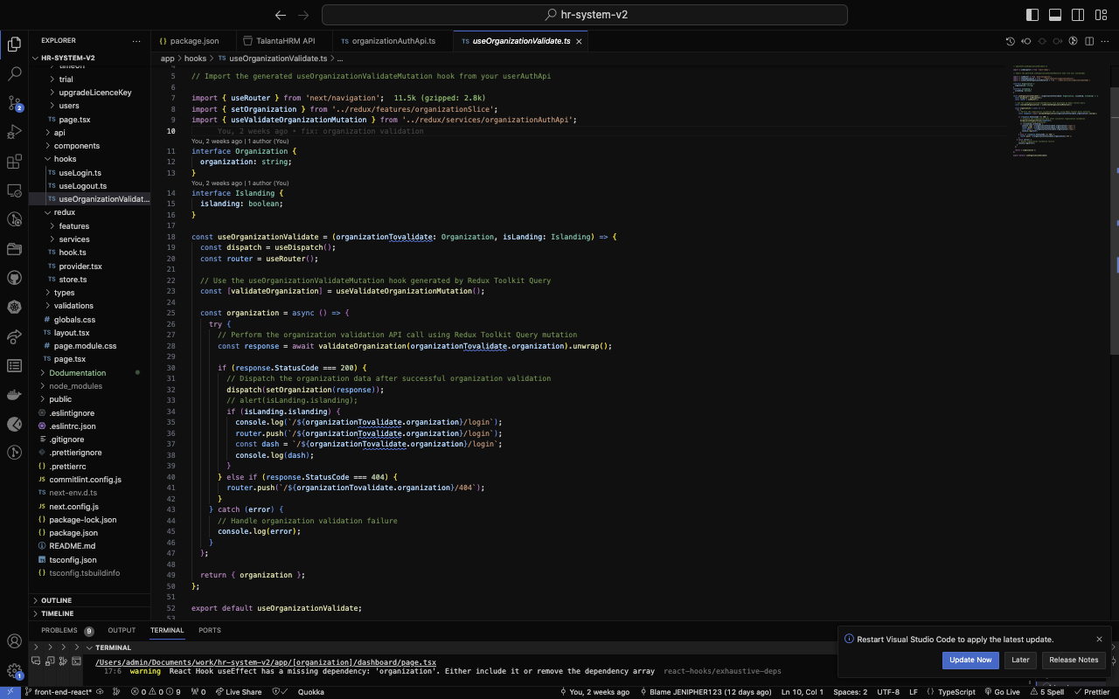

- Wrong/ non-existant organization navigates you to the 404 page

**NB**: if you are logged in it logs you out and redirects you to the error page

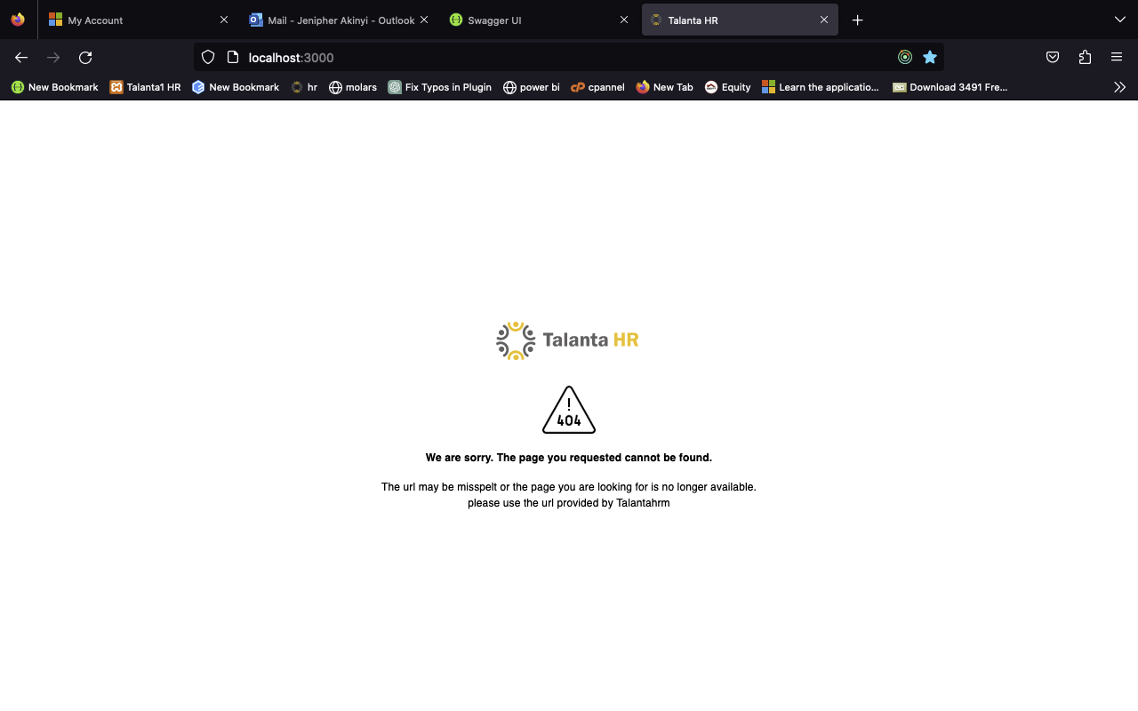

- Upon success navigate to login page if user isnt logged in



1. **User Authentication**

- Login UI



-Login API intergration

Endpoint:

<https://api/talantahrm.com/oauth/v1/generate>

error loggin in:

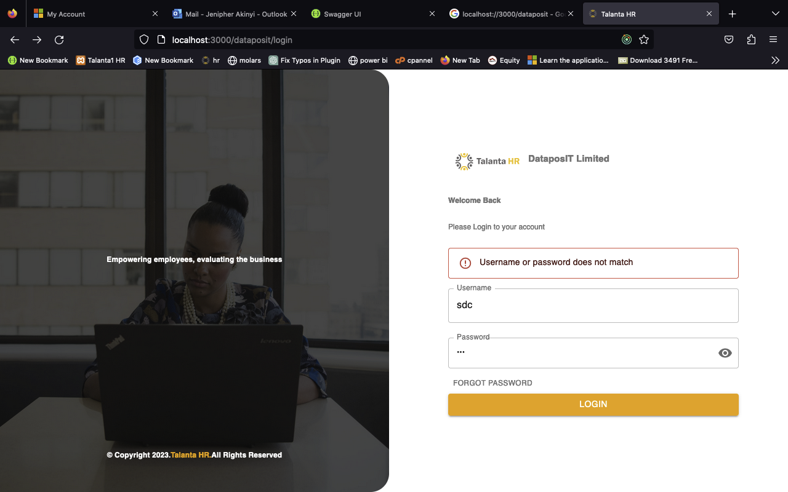

Success loggin in redirects to dash:

**NB: DESIGN STILL IN PROGRESS....**

